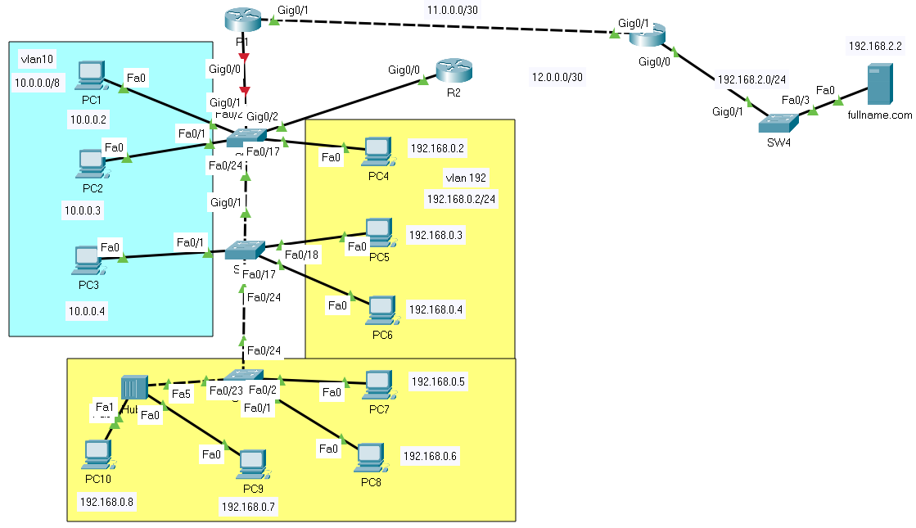

1. **Create a diagram.**
2. **Configure VLAN 10 and 192 on 2 switches SW1 and SW2**

* Trunk for ports g0/1 and g0/2

DONE

* Ports f0/1-10 belong to VLAN 10, f0/11-24 belong to VLAN 192

1. **Configure VLAN 192 on switch SW3: ports f0/1-24 belong to VLAN 192**

1. **Answer the following questions:**

* Ping from PC1 to PC2. Result? If successful: Shown the MAC address table values of SW1 and SW2.
  + Địa chỉ ip và subnetmask vào PC1 and PC2 là ping dc
* Switch to simulation mode and then check the packet sent from PC3 to PC1: Shown the MAC address table values of SW1 and SW2, Shown the ARP table value of PC1
  + A computer screen shot of a program

    Description automatically generated

ARP là gói quảng cáo

A broadcast domain : là miền quảng cáo

* Switch to simulation mode and then check the packet sent from PC8 to PC4: Shown the MAC address table values of SW1 and SW2, Shown the ARP table values of PC4, PC5, and PC8
* Ping from PC10 to PC4: Is it successful? Why? Differences between Hub and Sw
* Switch to simulation mode and then check the packet sent from PC1 to PC4: Is it successful? Why?
  + Khác vlan . NO sucess
* How many Broadcast domains in the diagram
  + 1 cổng nối vào router là 1 miền quảng cáo
* How many Collision domains of Hub
  + Duy nhất 1
* How many Collision domains of SW3.
  + Mỗi dây nối vào là 1 miền
  + Có 3 miền

1. **Configure IP addresses on R1, R3, and EIGRP routing for network communication.**

* Switch to simulation mode and then check the packet sent from PC1 to PC4: Is it successful? Why?

* Switch to simulation mode and then check the packet sent from PC1 to server fullname.com: Is it successful? Why?

DONE

1. **Connect the cable from R2 to R3 and configure additional EIGRP routing on router R2**

Note: Interface G0/0 of R2 is divided into 2 subinterfaces (g0/0.10 (10.0.0.254/8) and g0/0.192 (192.168.0.254/24)).

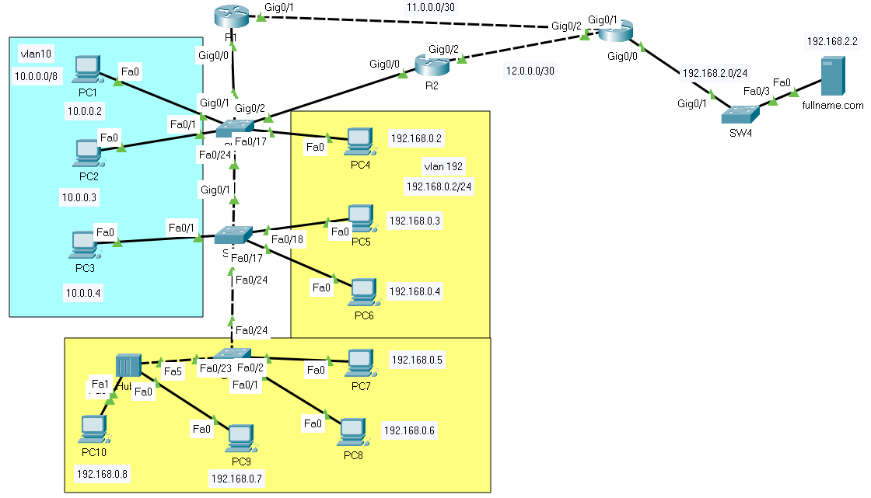

1. **Configure FHRP (First Hop Redundancy Protocol) service using Cisco's Hot Standby Router Protocol (HSRP)**

***- R1: Reset IP for both ports (g0/0.10: 10.0.0.253/8 and g0/0.192: 192.168.0.253/24) then configure virtual Default Gateway for 2 networks (Vlan 10 and Lan 192):***

R1(config-subif)#int g0/0.10

R1(config-subif)#standby 1 ip 10.0.0.1

R1(config-subif)#standby 1 priority 150 *(0-255 (default: 100))*

R1(config-subif)#standby 1 preempt

*Do the same for g0/0.192*

***- R2: Configure virtual Default Gateway for 2 network:***

R2(config-subif)#int g0/0.10

R2(config-subif)#standby 1 ip 10.0.0.1

R2(config-subif)#standby 1 preempt

*Do the same for g0/0.192*

1. **Connectivity check**

* Check the connection from PC1 and PC4 to server fullname.com
* Shutdown port g0/0 of R1 then recheck the connection from PC1 and PC4 to server fullname.com

1. **Basic configuration at Switch SW1: Hostname, banner Password in user and privileged mode, secret password Encrypt all passwords.**
2. **Telnet configuration at SW1, SW2, SW3 with password as 12345, assign IP to vlan 10 interface on these switches, set the default gateway of vlan 10 for all 3 switches.**

***Configuration at switch SW1:***

*Telnet:*

SW1(config)#line vty 0 4

SW1(config-line)#password 12345

SW1(config-line)#login

SW1(config-line)#exit

*Assign IP to vlan:*

SW1(config)#int vlan 10

SW1(config-if)#ip add 10.0.0.250 255.0.0.0

SW1(config-if)#exit

*Configure default gateway:*

SW1(config)#ip default-gateway 10.0.0.1

Access via telnet from server fullname.com to the switches.

1. **SSH configuration at R1**

- Configure a domain name

R1(config)#ip domain-name fullname.com

- Configure accounts for SSH access:

R1(config)#username fullname password 12345

- Configure the router to generate keys for data encryption:

R1(config)#crypto key generate rsa

- Configure VTY lines to support SSH access:

R1(config)#line vty 0 4

R1(config-line)#transport input ssh

R1(config-line)#login local